Rock Identification 1: Sedimentary Rocks
Name:___________________________________ Block:____________ Partners:_____________________
Pre-Lab questions:
- In order for a sedimentary rock to form, the presence of what earth material is required?

- Geologists classify sedimentary rocks into which three groups (based on differences in how they form)?

- Clastic sedimentary rocks are always formed from what?

- How does a crystalline sedimentary rock differ from a clastic one? How would they appear differently?

- What does the term “bioclastic” mean?

- Circle all words that could be used to describe identifiable features of sedimentary rocks
Layering Foliation Banding Fossils Sediments Glassy Vesicular (gas pockets) Crystals

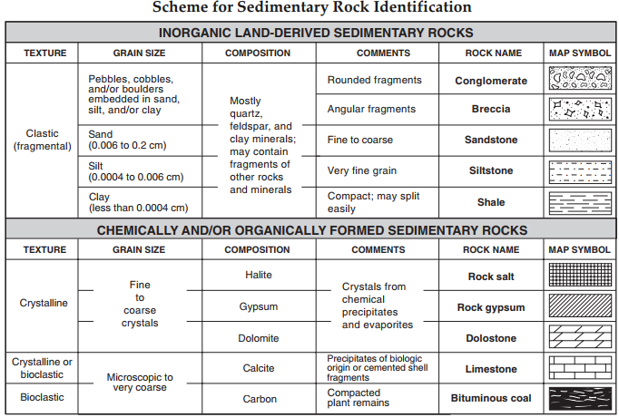

Sample | Texture (Clastic, Crystalline, Bioclastic) | Grain Size- pebbles, sand, silt, clay, Mixed  If crystalline- course or fine ) | Notable characteristics  Ex: Fossils? Layers? Rounded or angular sediments? Will fizz with acid…. | Name of the identified rock
S-A

S-B

S-C

S-D

S-E

S-F

S-G

S-H

Conclusion question: A river carrying a large sediment load enters the ocean. Naturally, the speed at which the water moving in the river decreases, and sediments begin to settle out and deposit along the ocean floor. In the diagram below, label where you believe the following rocks would form, according to their sediment size: Conglomerate, Sandstone, Siltstone, Shale. Provide a brief explanation for your choices above the labels below.

